**CHAPTER 01**

**1.0 INTRODUCTION**

Exercise is advised for health promotion among the exercises aerobic exercises some are running, jogging, walking, cycling and others. Among different modes of exercises in the modern busy life, the cycling and treadmill exercises are the commonest to perform indoor.

Treadmill bike is basically a new concept for travelling and exercising. It eliminates most of the issues related to both. As we know how important exercise is in stressful world this would helps to maintain our health.

Normal bicycle will run by pedalling but walking bicycle run by treadmill process. The mechanical design of this has a 90cm*40cm treadmill conveyor belt and the conveyor rotation is converted into linear motion with the help of spur gear through the bicycle moves front side.

A speedometer is connected near the front wheel to indicate speed of the treadmill bike. PIC16F877A is used to control the walking bicycle. A pulse sensor is added to display the pulse rate of the rider on the bicycle

**CHAPTER 02**

**2.0 PROJECT IN BRIEF**

**2.1 Aim**

To design a multi-task, eco-friendly walking bicycle.

**2.2 Objectives**

* To control pollution.
* To reduce the use of non-renewable energy sources.
* To design an eco-friendly model bicycle.

**2.3 PROJECT TARGET**

Our target is to achieve a system which incorporates technology and the system which will help in physical fitness of people.

**CHAPTER 03**

**EXISTING MODULAR BLOCK DIAGRAM**

MODULE 1

230V

AC

50Hz

12V DC/1.2A

12V

DC

1.2A

Lead Acid

Battery

12V/1.2Ah

Charging Circuit

MODULE 2

12VDC/1.2A 5V DC/1.2A

From Battery

Regulator

IC 7805

MODULE 3

Lead Acid Battery 12V/7Ah

24VDC/7Ah

Lead Acid Battery 12V/7Ah

MODULE 4

5V/1.2A

MODULE 7

P

I

C

1

6

F

8

7

7

A

MODULE 5

5V/1.2A

LCD display

16*2

5V/1.2A

Speed Sensor

MODULE 8

24V/7Ah

MODULE 6

HUB Motor Controller

5V/1.2A

HUB Motor

300 RPM

PIR Sensor

**PROPOSED MODULAR BLOCK DIAGRAM**

MODULE 1

230V

AC

50Hz

12V DC/1.2A

12V

DC

1.2A

Lead Acid

Battery

12V/1.2Ah

Charging Circuit

MODULE 2

12VDC/1.2A 5V DC/1.2A

From Battery

Regulator

IC 7805

MODULE 3

Lead Acid Battery 12V/7Ah

24VDC/7Ah

Lead Acid Battery 12V/7Ah

MODULE 4

MODULE 5

5V/1.2A

5V/1.2A

MODULE 7

P

I

C

1

6

F

8

7

7

A

Speed Sensor

5V/1.2A

MODULE 6

LCD display

16*2

5V/1.2A

MODULE 8

PIR Sensor

24V/7Ah

MODULE 9

HUB Motor Controller

5V/1.2A

HUB Motor

300 RPM

PULSE SENSOR

**CHAPTER 04**

**COMPARISON OF EXISTING WITH PROPOSED MODEL**

|  |  |
| --- | --- |
| **EXISTING MODEL** | **PROPOSED MODEL** |
| * In existing module the speed sensor is to display the speed of the walking bicycle. | * In existing module the speed sensor to display the speed of the walking bicycle. * In proposed module the Pulse sensor which indicates the heart beat rating of the humans who are walking on the bicycle and it’s displayed in the display. |

**CHAPTER 5**

**BLOCK DIAGARAM DESCRIPTION**

**MODULE 1: BATTERY AND CHARGING CIRCUIT**

* An 12V lead acid battery is used to power this project.
* Lead acid battery is less in weight and compact in size.
* It can be charged by using a charging circuit.

**MODULE 2: 5V POWER SUPPLY**

* A power supply provides the required voltage and current for electronic components.
* This module mainly consists of a LM7805 IC which is used to get 5V / 1.2A output.
* It is provided with an 12V/1.2A input from the battery to get 5V output for certain modules.

**MODULE 3: 24V BATTERY**

* The battery 12V/7Ah two batteries are connected in series to provide required voltage for the HUB motor.
* So the required voltage for the HUB motor is 24V/7Ah will be obtained by this module.

**MODULE 4: PIC16F877A MICROCONTROLLER**

* A microcontroller (or MCU for microcontroller unit) is a small computer on a single integrated circuit.
* A microcontroller contains one or more CPUs (processor cores) along with memory and programmable input/output peripherals.
* Microcontrollers are designed for embedded applications.

**MODULE 5: SPEED SENSOR**

* US 1881/04E is used to detect the speed of the bicycle.
* It’s operating voltage range from 3.5V to 24V.
* It is low current consumption.
* CMOS technology.

**MODULE 6: PIR SENSOR**

* It is used as motion detector to on the display.
* It’s effective range of about ten meters.
* It operating voltage is 5V.
* It consumption low power.
* It is easy to interface.

**MODULE 7: LCD DISPLAY**

* It is a 16*2 LCD used to display the title.
* Its operating voltage is 5V.

**MODULE 8: HUB MOTOR**

* In this project the HUB motor is used to move the bicycle in forward direction and to boost up the bicycle.
* The HUB motor is of 300 RPM.
* It runs in voltage of 24V/7A.
* The speed for the motor is controlled by throttle.

**MODULE 9: PULSE SENSOR**

* TCRT100 works under the principle of photo plethysmography.
* This module uses bright infrared (IR) LED and a phototransistor to detect the pulse of the finger, a red LED flashes with each pulse.
* It’s operating voltage is 5V

**CHAPTER 06**

MODULE 1

**BATTERY & CHARGING CIRCUIT**

**CONTENTS**

* 6.1-DESCRIPTION
* 6.2-BLOCK DAIGRAM
* 6.3-SCHEMATIC DIAGRAM
* 6.4-BILL OF MATERIALS

**6.1- DESCRIPTION**

* Charging Circuit it is an electric circuit or path that extends from a charging source to a battery, cell, or capacitor to be charged.
* His requirement was a circuit to charge two 12V/7AH lead acid batteries in series.
* The no of cells/battery is also an important parameter and here I designed the circuit assuming each 12V battery containing 6 cells.
* When two batteries are connected in series, the voltage will add up and the current capacity remains same.
* So two 12V/7AH batteries connected in series can be considered as a 24V/7AH battery.

**6.4-BILL OF MATERIAL**

|  |  |  |  |
| --- | --- | --- | --- |
| **SLNO** | **ITEM DESCRIPTION** | **SYMBOL** | **QUANTITY (NO'S)** |
| 1 | Lead acid Battery (12V/1.2Ah) | Bt 1 | 1 |
| 1 | Battery adapter (12V/1.2Ah) | Bat | 1 |

**CHAPTER 07**

MODULE 2

**POWER SUPPLY**

**CONTENTS**

* 7.1- DESCRIPTION
* 7.2- BLOCK DAIGRAM
* 7.3- SCHEMATIC DIAGRAM
* 7.4- BILL OF MATERIALS

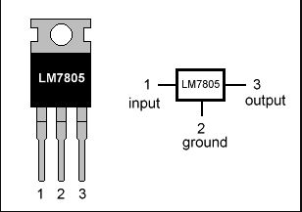

**7.1- DESCRIPTION IMAGE**

**7805** is a**voltage regulator**integrated circuit. It is a member of 78xx series of fixed linear voltage regulator ICs. The voltage source in a circuit may have fluctuations and would not give the fixed voltage output. The **voltage regulator IC** maintains the output voltage at a constant value. The xx in 78xx indicates the fixed output voltage it is designed to provide. 7805 provides +5V regulated power supply. Capacitors of suitable values can be connected at input and output pins depending upon the respective voltage levels.

**POWER SUPPLY**

* A power supply is an electrical device that supplies [electric power](https://en.wikipedia.org/wiki/Electric_power) to an [electrical load](https://en.wikipedia.org/wiki/Electrical_load).
* The primary function of a power supply is to convert [electric current](https://en.wikipedia.org/wiki/Electric_current) from a source to correct [voltage](https://en.wikipedia.org/wiki/Voltage), [current](https://en.wikipedia.org/wiki/Electric_current), and [frequency](https://en.wikipedia.org/wiki/Frequency) to power the load.
* As a result, power supplies are sometimes referred to as [electric power converters](https://en.wikipedia.org/wiki/Electric_power_converter).
* Some power supplies are separate standalone pieces of equipment, while others are built into the load appliances that they power.
* Other functions that power supplies may perform include limiting the current drawn by the load to safe levels, shutting off the current in the event of an [electrical fault](https://en.wikipedia.org/wiki/Electrical_fault).
* Power conditioning to prevent [electronic noise](https://en.wikipedia.org/wiki/Electronic_noise) or [voltage surges](https://en.wikipedia.org/wiki/Voltage_surge) on the input from reaching the load, [power-factor correction](https://en.wikipedia.org/wiki/Power-factor_correction), and storing energy so it can continue to power the load in the event of a temporary interruption in the source power.

**REGULATOR:**

We are using regulator ICs to maintain a constant output voltage in a power supply circuit. Regulator IC 7805 is used for getting 5V.

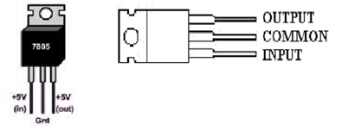

**7805 voltage regulator**

The IC7805 is simple to use. Connect the positive lead form unregulated DC power supply to the input pin, connect the negative lead to the common pin and then turn on the power, a 5-volt supply from the output pin will be obtained.

**7.2-BLOCK DIAGRAM**

5V, 1.2A

Regulator

IC 7805

Filter capacitor

12V, 1.2A

From battery

**7.3- CIRCUIT DIAGRAM**

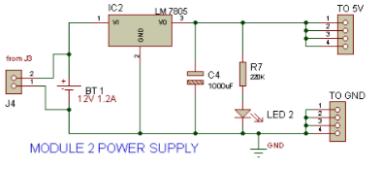

**7.4- BILL OF MATERIALS**

|  |  |  |  |
| --- | --- | --- | --- |
| **SL. NO** | **ITEM DESCRIPTION** | **SYMBOL** | **QUANTITY** |
| 1 | Lead acid rechargeable battery (12V/1.2A) | BT1 | 1 |
| 2 | Regulator (5V/1A)/12 V, KCS (TO-220) IC 7805 | IC2 | 1 |
| 3 | DC capacitor (1000µF,25V) (55°C To 150°C) | C4 | 1 |
| 4 | Carbon Resistor, Axial lead ¼ Watts, 220kΩ | R7 | 1 |
| 5 | Radial LED 3mm (Red) | LED 2 | 1 |
| 6 | SIL connectors (male -male, female-male, female-female) |  | 10 |
| 7 | General purpose PCB(80*80)mm |  | 1 |
| 8 | clip-on battery |  | 1 |

**CHAPTER 08**

MODULE 3

**BATTERY**

**CONTENTS**

* 8.1- DESCRIPTION
* 8.2- BLOCK DAIGRAM
* 8.3- SCHEAMATIC DIAGRAM
* 8.4- BILL OF MATERIALS

**8.1- DESCRIPTION**

This lead acid battery charger circuit is designed in response to a request from. His requirement was a circuit to charge two 12V/7AH lead acid batteries in series. The no of cells/battery is also an important parameter and here I designed the circuit assuming each 12V battery containing 6 cells. When two batteries are connected in series, the voltage will add up and the current capacity remains same. So two 12V/7AH batteries connected in series can be considered as a 24V/7AH battery

**8.2-BLOCK DIAGRAM**

24VDC/7Ah

Lead Acid Battery 12V/7Ah

Lead Acid Battery 12V/7Ah

**CIRCUIT DIAGRAM**

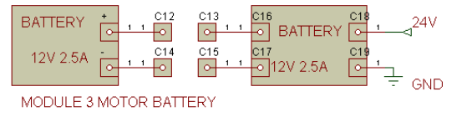

**8.4- BILL OF MATERIALS**

|  |  |  |  |
| --- | --- | --- | --- |
| **SL NO** | **ITEM DESCRIPTION** | **SYMBOL** | **QUALITY** |
| 1 | Rechargeable battery (12V/7Ah) | BT2 | 2 |
| 2 | Lead acid Battery adapter (12V/7Ah) | Bat 2 | 1 |

**CHAPTER 9**

MODULE 4

**PIC16F877A**

**CONTENTS**

* 9.1- DESCRIPTION
* 9.2- FEATURES
* 9.3- PIN DESCRIPTION
* 9.4- CIRCUIT DIAGRAM
* 9.5- BILL OF MATERIAL



**9.1- DESCRIPTION**

Microprocessors brought the concept of programmable devices and made many applications of intelligent equipment. Most applications, which do not need large amount of data and program memory, tended to be costly.

The microprocessor system must satisfy the data and program requirements so, sufficient RAM and ROM are used to satisfy most applications. The peripheral control equipment also need to be satisfied. Therefore, almost all-peripheral chips were used in the design. Because of these additional peripherals cost will be comparatively high.

In comparison, a midrange Microcontroller PIC16F877A chip has all that and it has some another additional feature also.

On comparing a board full of chips (Microprocessors) with one chip with all components in it (Microcontroller).

**ADVANTAGES**

1. Less number of instructions to learn.
2. RISC architecture.
3. Built-in oscillator with selectable speeds.
4. Easy entry level, in-circuit programming plus in-circuit debugging PIC kit units available for less than 2000.
5. Inexpensive microcontrollers.
6. Wide range of interfaces including I²C, SPI, USB, USART, A/D, programmable comparators, PWM, LIN, CAN, PSP, and Ethernet.
7. Availability of processors in DIL package make them easy to handle for hobby use.

**MICROCONTROLLER PIC16F877A**

The controller unit controls the entire movement of the hovercraft. So, PIC16F877A is used as our controller. PIC16F877A is an MICROCHIP family microcontroller used to control the movement of the hovercraft. It is a low power, high performance CMOS 8-bit microcontroller with 8k bytes programmable memory.

The PIC16F877A belongs to the PIC family of Microcontrollers. It features all the components which modern microcontrollers normally have. For its low price, wide range of application, high quality and easy availability, it is an ideal solution in applications such as:

The control of different processes in industry.

Machine control devices.

Measurement of different values etc.

The PIC16F877A CMOS FLASH-based 8-bit Microcontroller is upward compatible with the PIC16C5x, PIC12Cxxx and PIC16C7x devices.

It features 20 ns instruction execution, 256 bytes of EEPROM data memory, self- programming, an ICD, 2 comparators, 8 channels of 10-bit Analog-to-Digital (A/D) converter, 2 capture/ compare/ PWM functions, a synchronous serial port that can be configured as either 3-wire SPI or 2-wire I2C bus, a USART, and a parallel slave port.

**9.2 - FEATURES OF PIC16F877A:**

1. Operating speed: 20Mhz, 200ns instruction cycle.
2. Operating voltage: 4.0-5.5 volts.
3. Industrial temperature range (-40 to +85 degrees).
4. 15 Interrupt sources.
5. 35 single word instructions.

### LIMITATION

* Register-bank switching is required to access the entire RAM of many devices.
* Operations and registers are not orthogonal; some instructions can address RAM and/or immediate constants, while others can use the accumulator only.

**DEBUGGING:**

Lots of Microprocessor circuitry and program to debug. In Microcontroller, there is no Microprocessor circuitry to debug.

**SLOWER DEVELOPMENT TIME:**

As per observed Microprocessors need a lot of debugging at board level and at program level, whereas, micro controller does not have the excessive circuitry and the built-in peripheral chips are easier to program for operation.

So, peripheral devices like Timer/Counter, Parallel programmable port, Serial Communication Port, Interrupt controller and so on, which were most often used were integrated with the Microprocessor to present the Micro controller. RAM and ROM also were integrated in the same chip. The ROM size was anything from 256 bytes to 32Kb or more. RAM was optimized to minimum of 64 bytes to 368 bytes or more.

Microprocessor has the following instructions to perform:

1. Reading instructions or data from program memory ROM.

2. Interpreting the instruction and executing it.

3. Read Data from I/O device.

4. Process the input read, as per the instructions read in program memory.

5. Read or write data to Data memory.

6. Write data to I/O device and output the result of processing to O/P device.

**SPECIAL MICROCONTROLLER FEATURES:**

Flash memory: 14.3 KB (8192 words).

Data SRAM: 368 bytes.

Data EEPROM: 256 bytes.

Self-reprogrammable under software control.

In-circuit serial programming via two pins.

Watchdog timer with on-chip RC oscillator.

Programmable code protection.

Power-saving code protection.

Selectable oscillator options.

In-circuit debug via two pins.

**PERIPHERAL FEATURES:**

Two 8-bit timer/counter (TMR0, TMR2) with 8-bit program.

One 16-bit timer/counter (TMR1).

High current source/sink for direct LED drive.

Watchdog Timer (WDT) with separate RC oscillator.

Two Capture, Compare, PWM Modules.

Synchronous serial port with SPI and I2 C.

Eight channel, 10- bit Analog-to-Digital converter.

Universal Synchronous Asynchronous Receiver Transmitter USART).

**ANALOG FEATURES:**

10-bit, 8-channel A/D converter.

Brown-out reset.

Analogue comparable module.

**CMOS TECHNOLOGY:**

Low-Power, high-speed Flash/EEPROM technology.

Fully static design, wide operating voltage range (2.0v to 5.5v). Commercial and Industrial rages.

Low-power consumption.

**INPUT/OUTPUT PORTS OF PIC16F877A:**

PIC16F877A series normally has five input/output ports. They are used for input/output interfacing with other devices/circuits. Most of these port pins are multiplexed for handling alternate function for peripheral features on the devices. All ports in a PIC chip are bidirectional. When the peripheral action is enable in a pin. It may not be used as its general input/output functions. The PIC 16F877A chip basically has 5 input/output ports. The 5 input /output ports and its functions are given below.

**PORTA AND TRISA REGISTERS:**

PORTA is 16-bit wide bi-directional port; the direction of this port is controlled by TRISA data direction register. Setting a TRISA (=1) makes corresponding PORTA pin as an input, clearing the TRISA (=0) making the corresponding PORTA pin as an output.

Pin RA4 is multiplexed with the “Timer0” module clock input to become the RA4 /T0CKI pin and functioning either input/output operation or timer 0 clock functioning module. The RA4/TOCKI is Schmitt Trigger input and an open-drain output.

Other PORTA pins in this microcontroller multiplexed with analog inputs and the analog Vref input for both the A/D converters and the Comparators. The operation of each pin is selected by clearing/ setting the appropriate control bits in the ADCON1 and/or CMCON registers. The TRISA register control the direction of the PORT pins even when they are being used as analog inputs. The user must ensure the bits in the TRISA register are maintained set when using them as analog inputs.

**PORTB AND TRISB REGISTERS:**

PORTB is also an 8-bit bi-directional PORT. Its direction is controlled and maintained by TRISB data direction register. Setting the TRISB into logic ‘1’ makes the corresponding “PORTB” pin as an input. Clearing the TRISB bit make PORTB as an output. Three pins of the PORTB are multiplexed with the In-circuit debugger and low-voltage programming function: RB3/PGM, Rb6/PGC and RB7/PGD for performing its alternate functions.

**PORTC AND TRISC REGISTERS:**

PORTC is an 8-bit wide, bi-directional PORT which controlled and maintained by TRISC data direction register. Setting a TRISC bit (= 1) will make the corresponding PORTC pin an input (i.e., put the corresponding output driver in a high-impedance mode). Clearing a C bit (= 0) will make the corresponding PORTC pin an output PORTC also multiplexed with several peripheral functions. PORTC pins have Schmitt Trigger input buffers.

When enabling peripheral functions, more care should be taken in defining TRIS bit for each PORTC pin as compared to other. Some peripheral override the TRIS bit to make a pin an output, while other peripheral override the TRIS bit to make a pin an input.

Since the other TRIS bits override is an effect while the peripheral is enabled, read-modify write instruction (BSF, BCF and XORWF) with TRISC as the destination, should be avoided. The user should prefer to the corresponding peripheral section for the correct TRIS bit settings.

**PORT D AND TRIS D REGISTERS:**

PORTD is an 8-bit PORT with bi-directional nature. This PORT also with Schmitt Trigger input buffers, each pin in this PORTD individually configurable as either input or output. PORTD can be configured as an 8-bit wide microprocessor PORT (functioning as parallel slave PORT) by setting control bit, PSP mode (TRIS E <4>). In this mode, the input buffers are TTL.0.

**PORT E AND TRIS E REGISTERS:**

PORTE has only three pins (RE0/RD/AN5, RE1/WR/AN6 and RE2/CS/AN7) which are individually configurable as inputs or outputs. These pins controllable by using its corresponding data direction register “TRISE”.

These pins also have Schmitt Trigger input buffers. The PORTE pins become I/O controls inputs for the Microprocessor PORTS when bit PSP mode is set.

In this mode, the user must make certain that TRISE bits are set and that pins are configured as digital inputs. Also, ensure that ADCON1 is configured for digital I/O.

In this mode, the input buffers are TTL. TRISE registers which also controls the parallel slave PORT operation. PORTE pins are multiplexed with analog input. When selected for analog inputs, these pins will read as ‘0’s.

TRIS E controls the direction of the RE pins, even when they are being used as analog inputs. The user must make sure to keep the pins configured as inputs when using them as analog inputs.

**PROGRAM MEMORY (FLASH)**

Itis used for storing a written program. Since memory is made in FLASH technology and can be programmed and cleared more than once, it makes this microcontroller suitable for device development.

**EEPROM**

Data memory that needs to be saved when there is no supply. It is usually used for storing important data that must not be lost if power supply suddenly stops. For instance, one such data is an assigned temperature in temperature regulators.

If during a loss of power supply this data was lost, we would have to make the adjustments once again upon return supply. Thus, our device losses self-reliance.

**RAM**

Data memory used by a program during its execution. In RAM are stored all inter-results or temporary data during run- time.

**FREE-RUN TIMER**

It is an 8-bit register inside a microcontroller that works independently of a program. On every fourth clock of the oscillator it increments its value until it reaches the maximum (255), and then it starts counting over again from zero, as we know the exact timing between each two increments of the timer contents, timer can be used for measuring time which is very useful with some devices.

**CENTRAL PROCESSING UNIT**

It has a role of connective element between other blocks in the microcontroller. It coordinates the work of other blocks and executes the user program.

**INTERRUPTS**

Interrupt is the signal sent to the microcontroller to make the event that requires immediate attentions, interrupt is requesting the processor to stop to perform the current program and to make time to execute a special code.

In fact, the method interrupt defines the option to transfer the information generated by internal or external system.

They are two types of interrupts Hardware and Software interrupts. Software interrupts come from a program that runs by the processor and requests the processor to stop running the program. Hardware interrupts these are sent microcontroller by hardware devices as third party, some of them can be masked by interrupt enable bit.

**PIN CONFIGURATION**

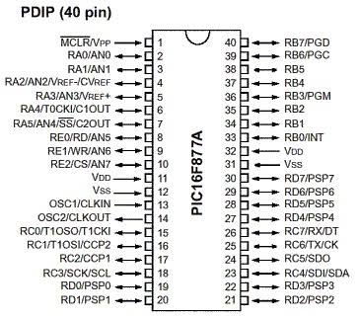

**9.3 - PIN DESCRIPTION**

MCLR - to reset the PIC (1)

VSS – ground (31)

VDD –power supply (32)

RB0 – port B pin 0 (33)

RB1 – port B pin 1 (34)

RB2 – port B pin 2 (35)

RB3 – port B pin 3 (36)

RB4 – port B pin 4 (37)

RB5 – port B pin 5 (38)

RB6 – port B pin 6 (39)

RB7 – port B pin 7 (40)

RA0 – port A pin 0 (2)

RA1 – port A pin 1 (3)

RA2 – port A pin 2 (4)

RA3 – port A pin 3 (5)

RA4 – port A pin 4 (6)

RA5 – port A pin 5 (7)

RE0 – port E pin 0 (8)

RE1 – port E pin 1 (9)

RE2 – port E pin 2 (10)

VDD – power supply (11)

VSS – ground (12)

OSC1 – connect to oscillator (13)

OSC2 – connect to oscillator (14)

RC0 – PORTC pin 0 (15)

RC1 – PORTC pin 1 (16)

RC2 – PORTC pin 2 (17)

RC3 – PORTC pin 3 (18)

RD0 – port D pin 0(19)

RD1 – port D pin 1 (20)

RD2 – port D pin 2 (21)

RD3 – port D pin 3 (22)

RC4 – PORTC pin 4 (23)

RC5 – PORTC pin 5 (24)

RC6 – PORTC pin 6 (25)

RC7 – PORTC pin 7 (26)

RD4 – port D pin 4 (27)

RD5 – port D pin 5 (28)

RD6 – port D pin 6 (29)

RD7 – port D pin 7 (30)

**ARCHITECTURE OF PIC16F877A**

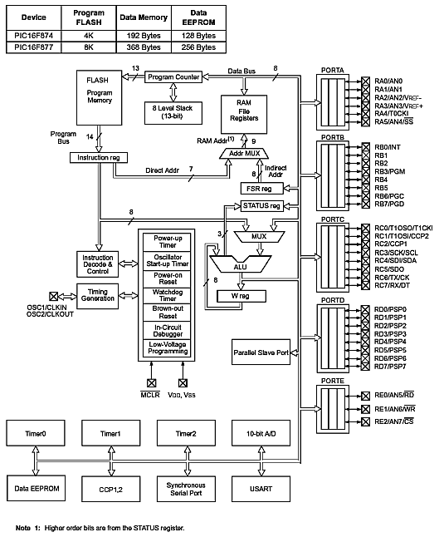

**CRYSTAL OSCILLATOR (OSCILLATOR CIRCUIT)**

* Oscillator circuit is known as the heartbeat of the microcontroller.
* The crystal oscillator will give the pulse used for working of a microcontroller.
* The frequency range of PIC16F877A is 4 MHz-20MHz.
* So we selected crystal with frequency 11MHz.
* C1 and C2 are total capacitance-to-ground at the input and output nodes of the amplifier, respectively.

### Special Microcontroller Features

* Flash Memory: 14.3 Kbytes (8192 words)
* Data SRAM: 368 bytes
* Data EEPROM: 256 bytes
* Self-reprogrammable under software control
* In-Circuit Serial Programming via two pins (5V)
* Watchdog Timer with on-chip RC oscillator
* Programmable code protection
* Power-saving Sleep mode
* Selectable oscillator options
* In-Circuit Debug via two pins

**9.4- CIRCUIT DIAGRAM**

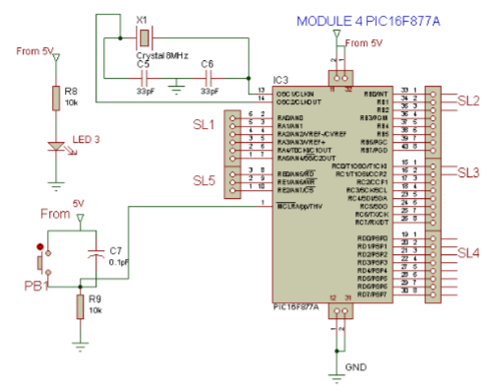

**9.5 BILL OF MATERIALS (PIC PCB)**

|  |  |  |  |
| --- | --- | --- | --- |
| SL NO | ITEM DESCRIPTION | SYMBOL | QUALITY  (NO’S) |
| 1 | PIC microcontroller board | U1 | 1 |
| 2 | Crystal oscillator (8MHz) | X1 | 1 |
| 3 | DC ( 33pF) -30°C to +125°C | C5&C6 | 2 |
| 4 | IC PIC16F877A DIP 40 Pin (5V,4HZ-20MZ | IC3 | 1 |
| 5 | DC capacitor (0.1µF,25V) (55°C To 150°C) | C7 | 1 |
| 6 | Carbon Resistor Axial lead ¼ Watts, 10K | R8&R9 | 2 |
| 7 | Push button A22N Series (22mm) | PB1 | 1 |
| 8 | SIL connectors male - male, female-female, male-female |  | 5 EACH |
| 9 | IC holder 40 Pin DIP (for PIC16F877A) |  | 1 |
| 10 | Radial LED 3mm (Red) | LED 3 | 1 |

**CHAPTER 10**

MODULE 5

### **SPEED SENSOR**

**CONTENTS**

* 10.1 DESCRIPTION
* 10.2 CIRCUIT DIAGRAM
* 10.3 FEATURES
* 10.4 BILL OF MATERIALS

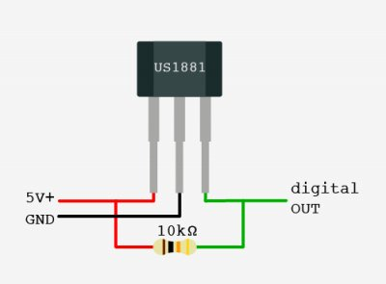

**10.1 DESCRIPTION**

The US1881 is the industry’s first Hall integrated circuit in a SOT – 23 packages. The US1881 is a bipolar Hall Effect sensor IC fabricated from mixed signal CMOS technology it incorporates advanced chopper stabilization techniques to provide accurate and stable magnetic switch points. There are many applications for this HED in addition to those listed above. The design, specifications and performance have been optimized for commutation applications in 5V and 12V brushless DC motors. The output transistor will be latched on (BOP) in the presence of a sufficiently strong South Pole magnetic field facing the marked side of the package. Similarly, the output will be latched off (BRP) in the presence of a North field. The SOT – 23 output transistors will be latched on in the presence of a sufficiently strong North Pole magnetic field subjected to the marked face.

**10.2 CIRCUIT DIAGRAM**

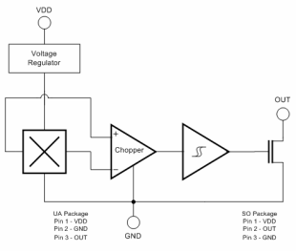

**10.3 FEATURES**

• Chopper stabilized amplifier stage

• Optimized for BDC motor applications

• New miniature package / thin, high reliability package

• Operation down to 3.5V

• CMOS for optimum stability, quality and cost

**10.4 BILL OF MATERIALS**

|  |  |  |  |
| --- | --- | --- | --- |
| **SL NO** | **ITEM DESCRIPTION** | **SYMBOL** | **QUALITY** |
| 1 | Speed sensor 5V/1.2A(US1881/04E) | SS | 1 |
|  |  |  | TOTAL |

**CHAPTER 11**

MODULE 6

**PIR SENSOR**

**CONTENTS**

* 11.1- DESCRIPTION
* 11.2- CIRCUIT DIAGRAM
* 11.3- FEATURES
* 11.4- BILL OF MATERIALS

**11.1 DESCRIPTION**

A passive infraredsensor (PIRsensor) is an electronic [sensor](https://en.wikipedia.org/wiki/Sensor) that measures [infrared](https://en.wikipedia.org/wiki/Infrared) (IR) light radiating from objects in its field of view. They are most often used in PIR-based motion detectors.

A PIR-based [motion detector](https://en.wikipedia.org/wiki/Motion_detector) is used to sense movement of people, animals, or other objects. They are commonly used in alarms and automatically-activated [lighting](https://en.wikipedia.org/wiki/Lighting) systems. They are commonly called simply "PIR", or sometimes "PID", for "passive infrared detector".

An individual PIR sensor detects changes in the amount of infrared radiation impinging upon it, which varies depending on the temperature and surface characteristics of the objects in front of the sensor. When an object, such as a [human](https://en.wikipedia.org/wiki/Human), passes in front of the background, such as a [wall](https://en.wikipedia.org/wiki/Wall), the temperature at that point in the sensor's field of view will rise from [room temperature](https://en.wikipedia.org/wiki/Room_temperature) to [body temperature](https://en.wikipedia.org/wiki/Body_temperature), and then back again. The sensor converts the resulting change in the incoming infrared radiation into a change in the output voltage, and this triggers the detection.

**11.2 CIRCUIT DIAGRAM**

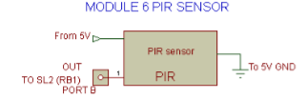

**11.3 FEATURE**

1. Complete with PIR, Motion Detection.
2. Dual Element Sensor with Low Noise and High Sensitivity.
3. Supply Voltage – 5V.
4. Delay Time Adjustable.
5. Standard TTL Output.

**11.4 BILL OF MATERIALS**

|  |  |  |  |
| --- | --- | --- | --- |
| SL NO | ITEM DESCRIPTION | SYMBOL | QUALITY  (NO’S) |
| 1 | PIR sensor HC-SR505 (5V/1.2A) | PIR | 1 |
|  |  |  | TOTAL |

**CHAPTER 12**

MODULE 7

**LCD DISPLAY**

**CONTENTS**

* **12.1 LCD DISPLAYDESCRIPTION**
* **12.2 CIRCUIT DIAGRAM**
* **12.3 BILL OF MATERIALS**

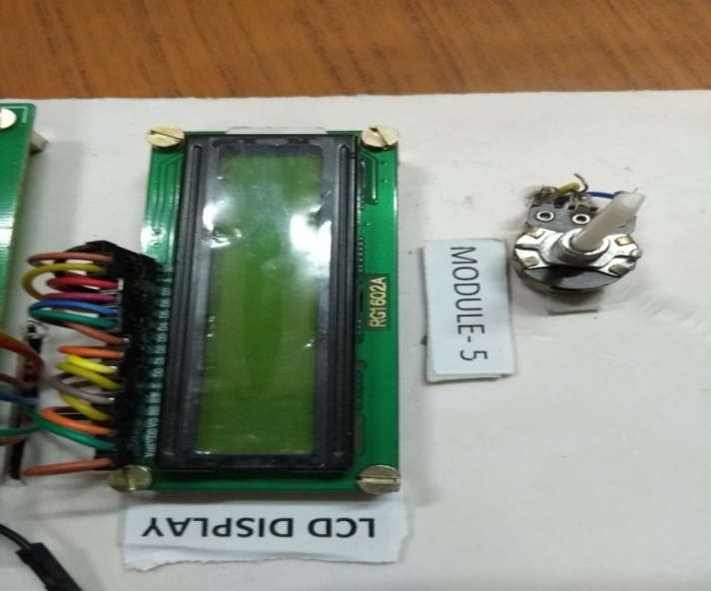

**12.1 DESCRIPTION**

Some displays can show only [digits](https://en.wikipedia.org/wiki/Numerical_digit) or [alphanumeric](https://en.wikipedia.org/wiki/Alphanumeric) characters. They are called segment displays, because they are composed of several segments that switch on and off to give appearance of desired [glyph](https://en.wikipedia.org/wiki/Glyph). The segments are usually single [LEDs](https://en.wikipedia.org/wiki/LED) or [liquid crystals](https://en.wikipedia.org/wiki/LCD). [Seven- segment display](https://en.wikipedia.org/wiki/Seven-segment_display) (most common, digits only)

* [Fourteen-segment display](https://en.wikipedia.org/wiki/Fourteen-segment_display)
* [Sixteen -segment display](https://en.wikipedia.org/wiki/Sixteen-segment_display)
* [HD44780 LCD controller](https://en.wikipedia.org/wiki/Hitachi_HD44780_LCD_controller) a widely accepted protocol for LCDs.

**12.2 CIRCUIT DIAGRAM**

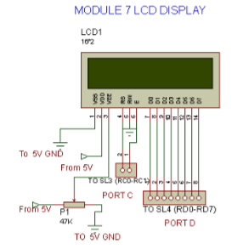

**12.3 BILL OF MATERIALS**

|  |  |  |  |
| --- | --- | --- | --- |
| SL NO | ITEM DESCRIPTION | SYMBOL | QUALITY  (NO’S) |
| 1 | LCD display (16*2) 5V/1.2A | LCD | 1 |
|  |  |  | TOTAL |

**CHAPTER 13**

MODULE 8

**HUB MOTOR**

**CONTENTS**

* **13.1 DESCRIPTION OF HUB MOTOR**
* **13.2 CIRCUIT DIAGRAM**
* **13.3 BILL OF MATERIALS**

**13.1 DESCRIPTIONS OF RELAY AND DC MOTOR**

**HUB MOTOR DESCRIPTIONS**

A hub motor is an electrical motor coupled to the wheels of a vehicle it is commonly used in electrical bicycle. The most commonly used hub motor is brushless DC motor owing to its high torque to weight ratio.

**HOW DOES A WHEEL HUB MOTOR WORKS**

But some of the latest electric cars and electric bicycle works in a different way instead of having one motor powering all the wheels using gears orChain they build a motor into directly the hub of each wheel so the motor and wheels are one and the same thing

**MOTOR**

An electric bicycle, also known as an e**-**bike**,** power bike or booster bike, is a [bicycle](https://en.wikipedia.org/wiki/Bicycle) with an integrated [electric motor](https://en.wikipedia.org/wiki/Electric_motor) which can be used for propulsion. There are a great variety of e-bikes available worldwide, from e-bikes that only have a small motor to assist the rider's pedal-power (i.e.pedaling) to somewhat more powerful e-bikes which tend closer to [moped](https://en.wikipedia.org/wiki/Moped)-style functionality: all, however, retain the ability to be [pedalled](https://en.wikipedia.org/wiki/Bicycle_pedal" \o "Bicycle pedal) by the rider and are therefore not [electric motorcycles](https://en.wikipedia.org/wiki/Electric_motorcycles). E-bikes use rechargeable batteries and the lighter varieties can travel up to 25 to 32 km/h (16 to 20 mph), depending on the laws of the country in which they are sold, while the more high-powered varieties can often do in excess of 45 km/h (28 mph). In some markets, such as Germany, they are gaining in popularity and taking some market share away from conventional bicycles while in others, such as China, they are replacing [fossil fuel](https://en.wikipedia.org/wiki/Fossil_fuel)-powered [mopeds](https://en.wikipedia.org/wiki/Moped) and small motorcycles.

Depending on local laws, many e-bikes are legally classified as bicycles rather than [mopeds](https://en.wikipedia.org/wiki/Moped) or [motorcycles](https://en.wikipedia.org/wiki/Motorcycle), so they are not subject to the more stringent laws regarding their certification and operation, unlike the more powerful two-wheelers which are often classed as [electric motorcycles](https://en.wikipedia.org/wiki/Electric_motorcycles). E-bikes can also be defined separately and treated as a specific vehicle type jurisdiction’s-bikes are the [electric motor](https://en.wikipedia.org/wiki/Electric_motor)-powered versions of [motorized bicycles](https://en.wikipedia.org/wiki/Motorized_bicycle), which have been around since the late 19th century. Some [bicycle-sharing system](https://en.wikipedia.org/wiki/Bicycle-sharing_system)s use them

E-bikes are classed according to the power that their electric motor can deliver and the control system, i.e., when and how the power from the motor is applied. Also the classification of e-bikes is complicated as much of the definition is due to [legal reasons](https://en.wikipedia.org/wiki/Electric_bicycle#Legal_status) of what constitutes a bicycle and what constitutes a moped or motorcycle. As such, the classification of these e-bikes varies greatly across countries and local jurisdictions.

Despite these legal complications, the classification of e-bikes is mainly decided by whether the e-bike's motor assists the rider using a pedal-assist system or by a power-on-demand one. Definitions of these are as follows:

* With pedal**-**assist the electric motor is regulated by pedalling. The pedal-assist augments the efforts of the rider when they are pedalling. These e-bikes – called pedicels – have a sensor to detect the pedalling speed, the pedalling force, or both. Brake activation is sensed to disable the motor as well.
* With power**-**on**-**demand the motor is activated by a [throttle](https://en.wikipedia.org/wiki/Throttle), usually handlebar-mounted just like on most motorcycles or scooters.

Therefore, very broadly, e-bikes can be classed as:

* E-bikes with pedal-assist only: either pedelecs (legally classed as bicycles) or S-Pedelecs (often legally classed as [mopeds](https://en.wikipedia.org/wiki/Moped))
* Pedelecs: have pedal-assist only, motor assists only up to a decent but not excessive speed (usually 25 km/h), motor power up to 250 watts, often legally classed as bicycles
* S-Pedelecs: have pedal-assist only, motor power can be greater than 250 watts, can attain a higher speed before motor stops assisting, legally classed as a moped or motorcycle (not a bicycle)
* E-bikes with power-on-demand and pedal-assist
* E-bikes with power-on-demand only: often have more powerful motors than pedelecs but not always, the more powerful of these are legally classed as mopeds or motorcycles

Pedal**-**assistonlyE-bikes with pedal-assist only are usually called pedelecs but can be broadly classified into pedelecs proper and the more powerful S-Pedelecs.

#### Pedelecs

Main article: Pedelec

The term "pedalling" (from pedal electric cycle) refers to an e-bike where the pedal-assist electric drive system is limited to a decent but not excessive top speed, and where its motor is relatively low-powered. Pedelecs are legally classed as bicycles rather than low-powered motorcycles or mopeds.

The most influential definition which distinguishes which e-bikes are pedelecs and which are not, comes from the EU. From the EU directive (EN15194 standard) for motor vehicles, a bicycle is considered a pedelec if:

1. the pedal-assist, i.e. the motorised assistance that only engages when the rider is pedalling, cuts out once 25 km/h is reached, and
2. When the motor produces maximum continuous rated power of not more than 250 watts ( the motor can produce more power for short periods, such as when the rider is struggling to get up a steep hill).

An e-bike conforming to these conditions is considered to be a pedelec in the EU and is legally classed as a bicycle. The EN15194 standard is valid across the whole of the EU and has also been adopted by some non-EU European nations and also some jurisdictions outside of Europe (such as the state of Victoria in Australia).

Pedelec are much like conventional bicycles in use and function — the electric motor only provides assistance, most notably when the rider would otherwise struggle against a headwind or be going uphill. Pedelecs are therefore especially useful for people living in hilly areas where riding a bike would prove too strenuous for many to consider taking up cycling as a daily means of transport. They are also useful when it would be helpful for the riders who more generally need some assistance, e.g. for elderly people.

#### S-Pedelecs

More powerful pedelecs which are not legally classed as bicycles are dubbed S**-**Pedelecs (short for Schnell-Pedelecs, i.e. Speedy-Pedelecs) in Germany. These have a motor more powerful than 250 watts and less limited, or unlimited, pedal-assist, i.e. the motor does not stop assisting the rider once 25 km/h has been reached. S-Pedelec class e-bikes are therefore usually classified as [mopeds](https://en.wikipedia.org/wiki/Moped) or motorcycles rather than as bicycles and therefore may (depending on the jurisdiction) need to be registered and insured, the rider may need some sort of driver's license (either car or motorcycle) and motorcycle helmets may have to be worn.

### Power-on- demand an pedal -assist

Some e-bikes combine both pedal-assist sensors as well as a throttle. An example and Adventure 24+ by BMEBIKES.

### Power-on- demandonly

Some e-bikes have an electric motor that operates on a power**-**on**-**demand basis only. In this case, the electric motor is engaged and operated manually using a throttle, which is usually on the handgrip just like the ones on a motorbike or scooter. These sorts of e-bikes often, but not always, have more powerful motors than pedelecs do.

With power-on-demand only e-bikes the rider can:

1. ride by pedal power alone, i.e. fully human-powered.
2. ride by electric motor alone by operating the throttle manually.
3. ride using both together at the same time.

Some power-on-demand only e-bikes can hardly be confused with, let alone categorized as, bicycles. For example, the Noped is a term used by the Ministry of Transportation of [Ontario](https://en.wikipedia.org/wiki/Ontario) for e-bikes which do not have pedals or in which the pedals have been removed from their motor raised bicycle. These are better categorized as electric [mopeds](https://en.wikipedia.org/wiki/Moped) or [electric motorcycles](https://en.wikipedia.org/wiki/Electric_motorcycle).

**13.2 CIRCUIT DIAGRAM**

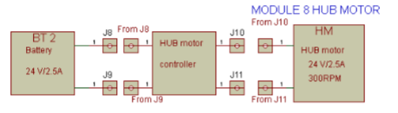

**13.3 BILL OF MATERIAL**

|  |  |  |  |
| --- | --- | --- | --- |
| SL NO | ITEM DESCRIPTION | SYMBOL | QUALITY  (NO’S) |
| 1 | HUB motor My 1016z2 (24V,7A) 300 RPM (loads up to 50 Kg), Throttle & controller | HM | 1 |

**CHAPTER 14**

MODULE 9

**PULSE SENSOR**

**CONTENTS**

* **14.1 PULSE SENSOR DESCRIPTION**
* **14.2 CIRCUIT DAIGRAM**
* **14.3 BILL OF MATERIALS**

**14.1 PULSE SENSOR DESCRIPTION**

The Pulse Sensor is a plug-and-play heart-rate sensor. It can be used by students, artists, athletes, makers, and game & mobile developers who want to easily incorporate live heart-rate data into their projects. Essence it is an integrated optical amplifying circuit and noise eliminating circuit sensor. Clip the Pulse Sensor to your earlobe or fingertip and plug it into your PIC you can ready to read heart rate.

**FEATURES**

* Working voltage: 5V
* Working current: 4mA

**14.2 CIRCUIT DIAGRAM**

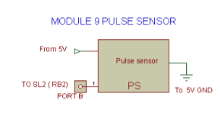

**14.3 BILL OF MATERIALS**

|  |  |  |  |
| --- | --- | --- | --- |
| SL NO | ITEM DESCRIPTION | SYMBOL | QUALITY  (NO’S) |
| 1 | Pulse sensor SEN 11574(5V/1.2A) | PS | 1 |

**CHAPTER 15**

**COMPONENTS OF WALKING BICYCLE**

Main components of Walking BICYCLE are:

• Tread belt.

• Motor.

**1 Tread Belt**

Tread belt comes in one-ply and two-ply options. One-ply tread belts are basically the cheapest option, needing replacement over time whereas two-ply tread belts are thicker and last much longer.

Some tread belts come with cushioning and impact absorption which is highly recommended for your joints and comfort level. People with muscles or joint problems or obese users are advised to opt for a more cushioned running surface.

Tread belts having harder surface may be used but cushioned docks are highly recommended. This is an important feature as it will help to make impact less jarring to your joints. Many treadmills can cushion up to 23% of the impact, with 12-14% being the average.

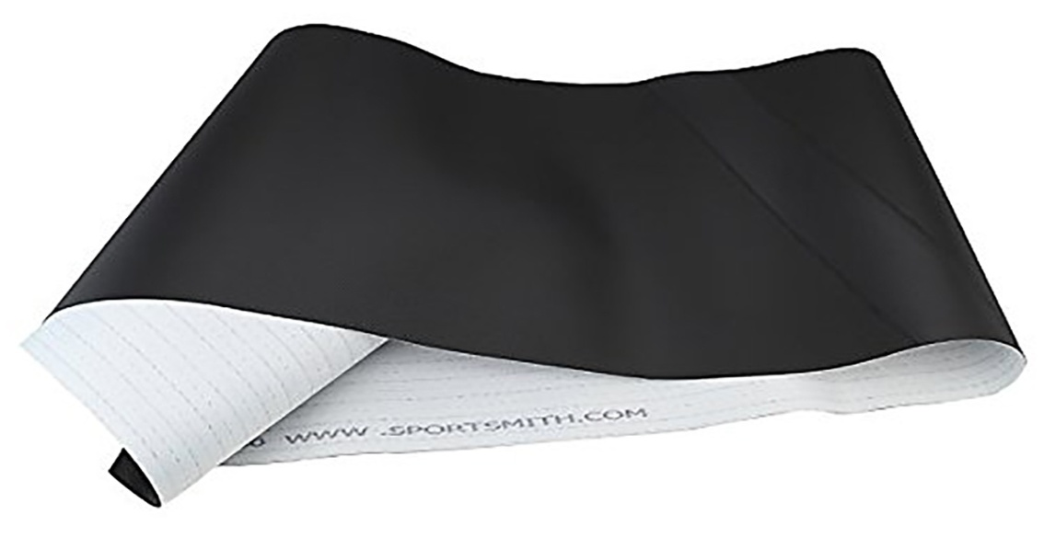

**REQUIRED COMPONENTS**

|  |  |  |  |  |  |
| --- | --- | --- | --- | --- | --- |
| **S No** | **Components** | **Material** | **FOS** | **Working stress (MPA)** | **Dimensions**  **(mm)** |
| 1 | Chassis | Stainless steel 304 | 3 | 61.59 | 35 |
| 2 | Fork | Stainless steel 304 | 4 | 42.09 | 40 |
| 3 | Bicycle axle | SAE 1010 Steel | 3.5 | 65.12 | 10 |
| 4 | Handle | Cast Aluminium alloy | 2.5 | 83.77 | 25 |
| 5 | Treadmill axle | Stainless steel | 3 | 13.14 | 12 |
| 6 | Roller | Mild steel | 2 | 38.24 | 20 |
| 7 | Side frame | Aluminium alloy | 3 | 10.83 | 70x30 |

**Selected Components**

The components we selected were brake, belt, bearings, suspension, motor, wheels. First of all we studied functional requirement of each components stated above. Then we select particular type of material of each component based on their functional requirement. We performed various calculations to find out dimensions and capabilities of each component.

|  |  |  |
| --- | --- | --- |
| Slno | **Component** | **Type/Material** |
| 1 | Motor | Brushless DC Motor |
| 2 | Bearing | Deep Groove Ball Bearing |
| 3 | Belt | Polyvinyl Chloride+Nylon |
| 4 | Brake-Front-Rear | Disk-Drum |
| 6 | Tyre | Rubber |

**3 MECHANICAL DESCRIPTIONS**

**MATERIAL SELECTION**

The materials used in this project are detailed as follows:

• Mild Steel.

• Nylon rubber fabric.

**4 Mild Steel:**

The frame of treadmill and front & rear rollers are made up of mild steel.

Reasons:

• Mild steel is readily available in market.

• It is economical to use.

• It is available in standard size.

• It has good mechanical properties i.e. it is easily machinable.

• It has moderate factor of safety, because factor of safety results in unnecessary wastage of material and heavy selection.

• It has high tensile strength.

• Low co-efficient of thermal expansion.

**Properties of Mild Steel:**

M.S. has carbon content from 0.15% to 0.30%. They are easily wieldable thus can be hardened only. They are similar to wrought in properties. Both ultimate tensile and compressive strength of these steel increases with increasing carbon content. They can be easily gas welded or electric or arc welded. With increase in the carbon percentage weld ability decreases. Mild steel serves the purpose and hence selected because of above purpose.

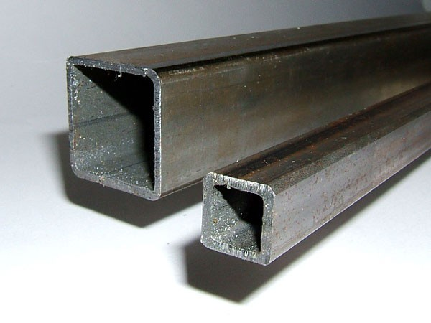

**5 Nylon Rubber Fabric:**

Standard material available for tread belt is nylon fabric. So we use this material for treadmill belt. Nylon rubber fabric is cheap and easily available, less in cost & having property of wear resistance.



**7- MECHANICAL DESIGN**

In our attempt to design a walking bike, we have adopted a very careful approach. Total design work has been divided into two parts mainly,

• System Design.

• Mechanical Design.

System design mainly concern with the various physical concern and ergonomics, space requirements, arrangement of various components on the main frame of treadmill, arrangement of tread belt and rollers, position of braking system, arrangement of motor, sprockets, ease of maintenance, scope of further improvements, ground clearance etc. In mechanical design, the components are categorized into two parts.

For design parts, detailed design is done and dimensions thus obtained are compared to next highest dimensions which are readily available in the market. This simplifies the assembly as well as post production servicing work. The various tolerances on work pieces are specified in the manufacturing drawing. The process sheets are prepared and passed on to the manufacturing drawing. The process sheets are prepared and pass on to the manufacturing stage. The parts are to be purchased directly are specified and selected from standard catalogue

**8 Treadmill Frame design:**

Material- Mild Steel. As the standard available tread belt size is (980*340) mm. Frame design is done according to the tread belt size. As per space availability and clearance for reduction of friction, frame size is (1090*410) mm

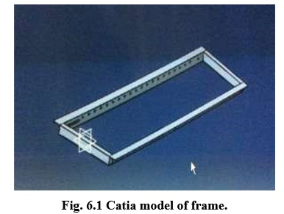

**9 Design of Front and Rear:**

Roller Width of the frame is 410 mm. So we choose length of rollers as 400mm. To reduce the friction of belt with frame 5 mm clearance is provided on both sides. Front roller is of diameter 58mm and that of rear one have diameter 49mm.

For easy and fast movement of belt some taper should be provided to belt that’s why front roller is large in diameter and rear is in small diameter. Rollers are connected to frame by using MS rod of diameter 10 mm. PVC bush are placed in front roller and deep groove ball bearing 6000, which is use for light weight operation is used. Rear roller is directly welded to 10mm MS rod.

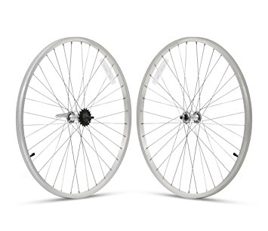

**10Design of Sprocket:**

**First Gear Reduction Ratio (motor to freewheel):**

i = n2/n1 i = 1.909

|  |  |  |
| --- | --- | --- |
| **Component** | **Speed** | **No. of teeth** |
| Motor | 300 rpm |  |
| Free wheel | 95.45 rpm | 22 |

**Second Gear Reduction Ratio.**

i = n2/n1 i = 1.235

|  |  |  |
| --- | --- | --- |
| **Component** | **Speed** | **No. of teeth** |
| Motor | 300 rpm |  |
| Free wheel | 61.75 rpm | 34 |

**Third Gear Reduction Ratio:**

i = n2/n1 i = 0.74

|  |  |  |
| --- | --- | --- |
| **Component** | **Speed** | **No. of teeth** |
| Free wheel | 95.45 rpm | 22 |
| Freewheel of Cycle | 70.68 rpm | 16 |

• 0.74Gear ratio is used to control the speed of cycle to 70.63 rpm and also to get more torque.

• We get more torque using this ratio and we can carry more weight on cycle.

**Final Output Ratios.**

|  |  |  |
| --- | --- | --- |
| **Primary gear reduction ratio** | **Secondary gear reduction ratio** | **Final gear reduction ratio** |
| 1.909 | 1.235 | 0.74 |

**Final Output Speeds.**

|  |  |  |
| --- | --- | --- |
| **Primary Speed** | **Secondary Speed** | **Final speed** |
| 300 rpm | 61.75 rpm | 70.63 rpm |

**12 MECHANICAL:**

* Steel
* Nuts & Bolts
* Washers
* Screws
* Insulation Tape

**CHAPTER 16**

**SCHEMATIC DIAGRAM**

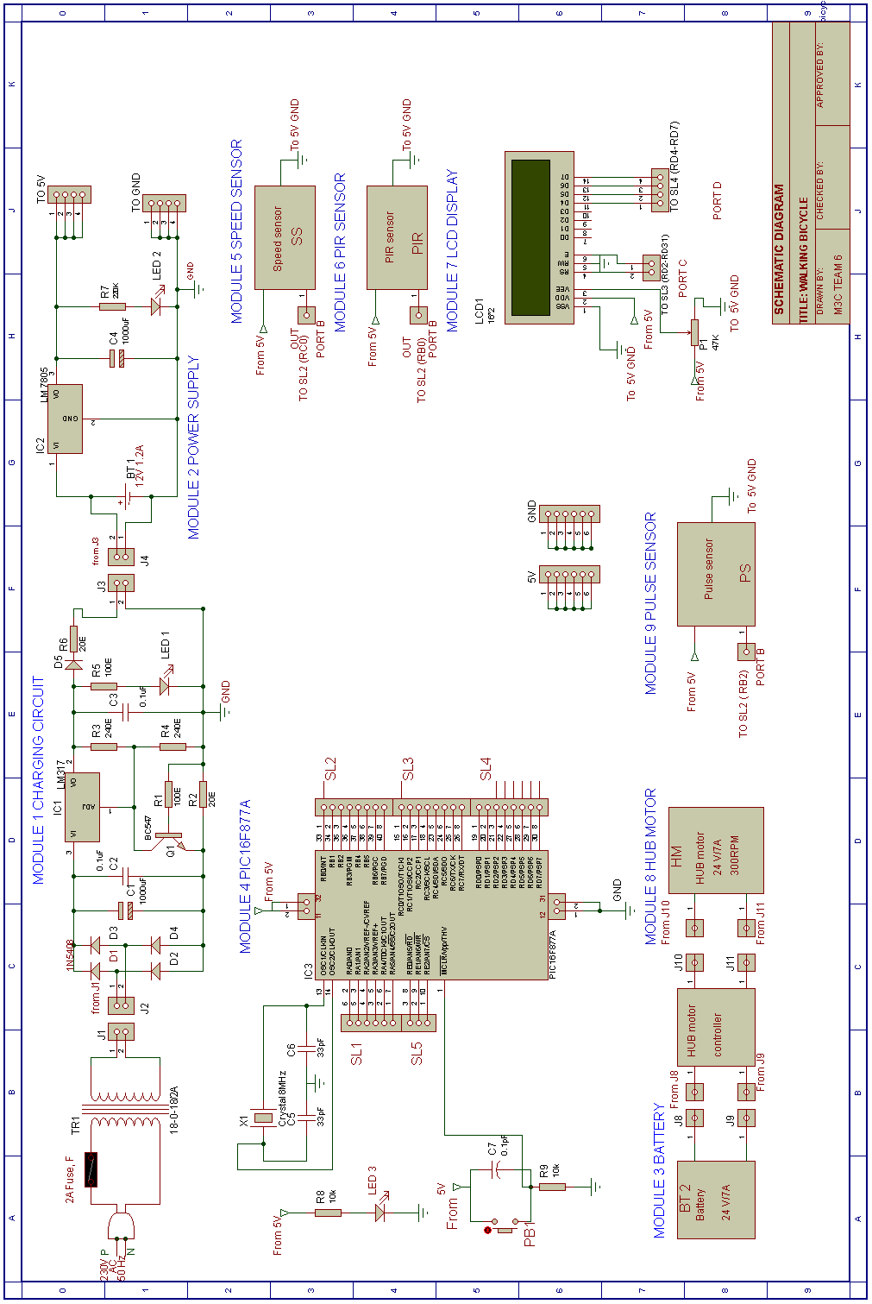

**INTERCONNECTION DIAGRAM**

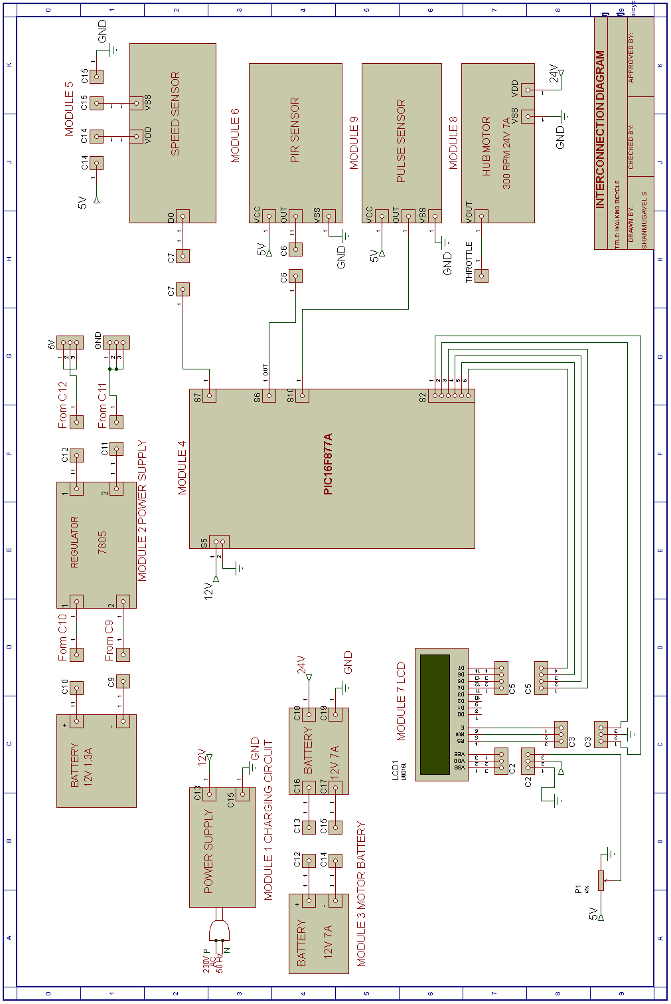

**CIRCUIT DIAGRAM**

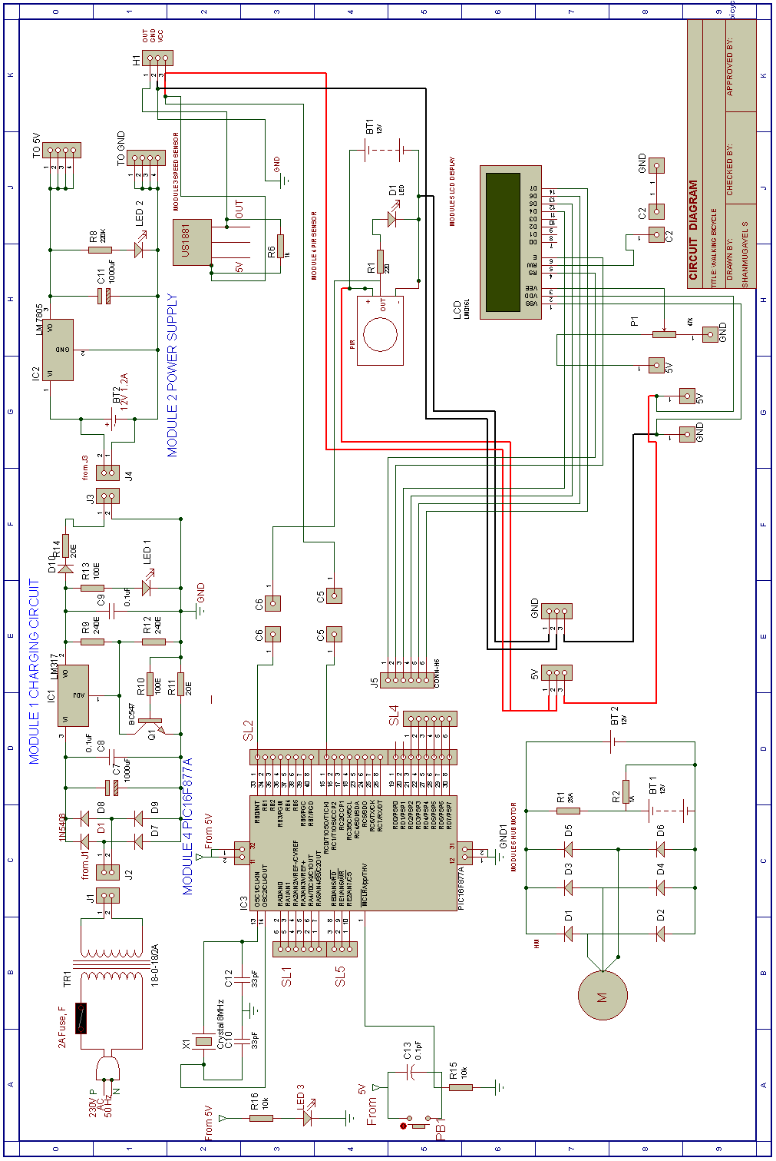

**CHAPTER 19**

**MECHANICAL DESIGN**

**ISOMETRIC VIEW**

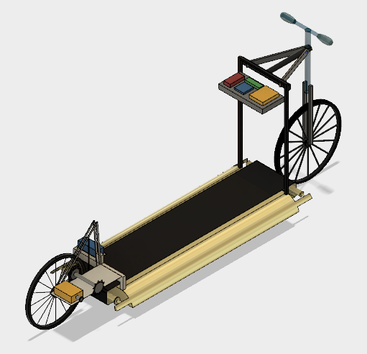

10

7

8

9

6

5

4

3

2

1

1-Handle 6-Power supply

2-Pulse sensor 7-Conveyor belt

3-Battery 8-Conveyor bed

4-LCD Display 9-PIR sensor

5-PIC16F877A 10-HUB motor

All dimensions are in mm

**FRONT VIEW**

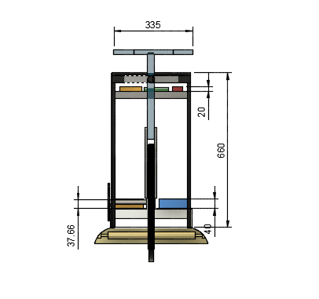

All dimensions are in mm

**SIDE VIEW**

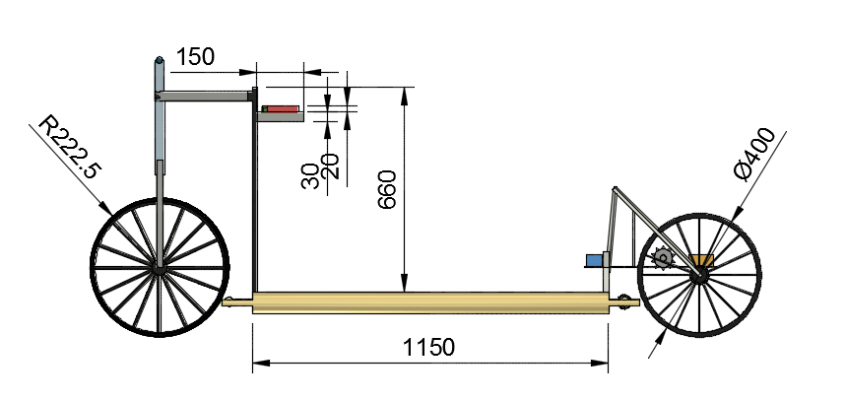

All dimensions are in mm

**TOP VIEW**

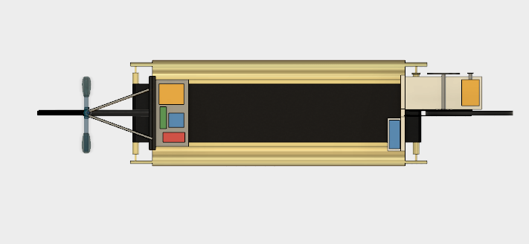

BATTERY

POWER SUPPLY

LC DISPLAY

PIC MICROCONTROLLER

CONVEYOR BED

CONVEYOR

WHEELS

HANDLE BAR

All dimensions are in mm

**WORKING DESCRIPTION**

**CONSTRUCTION**

1. The treadmill part and conveyor is fixed with the front and rear wheels.

2. And hand bar is present to drive the cycle.

3. The hub motor is mounted in the iron plates which are connected to the gear of treadmill.

4. And the speed sensor and pulse sensor is placed in the panel to show the speed and heart rate.

**WORKING**

The dc motor is placed on the iron plate present at the end of the back wheel, the chain is connected from the motor to belt at the center one more gear is present to convert the motion to the back wheel with the chain drive.

Then the cycle will move forward when we walk on the treadmill conveyor.

The motor will control by the diluter which is present in the handlebars right side.

**MECHANICAL DESIGN**

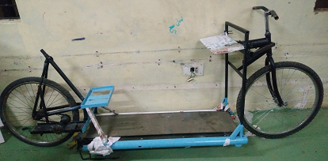

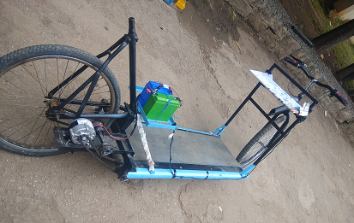

**CHAPTER 18**

**OVERALL BILL OF MATERIALS**

|  |  |  |  |  |
| --- | --- | --- | --- | --- |
| **SL.**  **NO** | **ITEM DESCRIPTION** | **SYMBOL** | **QUANTITY (NO'S)** | **PRICE (INR)** |
| 1 |  | BC | 1 | 448 |
| Battery |
| 2 | Battery charger | Bat1 | 1 | 150 |
| 3 |  | PS | 1 | 485 |
| Power supply |
| 4 |  | BT | 1 | 2700 |
| Battery |
| 5 |  | MC | 1 | 146 |
| Microcontroller 16F877A |
| 5 |  | ss | 1 | 100 |
| Speed Sensor |
| 6 |  | PIR | 1 | 180 |
| PIR Sensor |
| 7 |  | LCD | 1 | 120 |
| LC display |
| 8 |  | HM | 1 | 6666 |
| Hub Motor |
| 9 |  | PS | 1 | 350 |
| Pulse Sensor |
| 12 | Mechanical Component | - |  | 6720 |
| 13 | Tool Kit | TK |  | AVAILABLE |
| 14 | Program Burner PIC KIT 3 | PB |  | AVAILABLE |
| 15 | Female To Female ,Male To Female Connecting Wires | WIRE | 70 | 140 |
|  | **TOTAL PRICE :** | | | **18055** |

**CHAPTER 19**

**SOFTWARE USED**

1. **Autodesk fusion 360**

Autodesk fusion 360 used to draw the mechanical views, by this software

Designed the mechanical structure of walking bicycle project and drawn the isometric view, side view, front view and top view.

**2. PROTEUS 8 Professional**

This software was used to draw the Schematic diagram, Circuit diagram and the interconnection diagram. It was also used to simulate and test certain programs.

**3. MPLAB IDE V8.33**

The programming part of this project was done using this software. Debugging of the program was also done with this software.

**4. PIC-kit 3**

Program was burned on to the IC using this software.

**CHAPTER 20**

**FLOW CHART**

RIDER STAND ON THE BICYCLE

ON THE POWER BUTTON

IT WILL DISPLAY THE TITLE

IF

RB0=0

BICYCLE WILL MOVE

THROTTLE

IT WILL DISPLAY THE SPEED OF THE BICYCLE

IF

RC0=1

IT WILL DISPLAY THE PULSE OF THE RIDER

PULSE SENSOR

RIDER WILL APPLY THE BREAK TO STOP THE BICYCLE

**PROGRAM**

#define _XTAL_FREQ 1000000

#define RS RD2

#define EN RD3

#define D4 RD4

#define D5 RD5

#define D6 RD6

#define D7 RD7

#define Trigger RB0 //34 is Trigger

#include <htc.h>

int speed =0;

int milli_sec=0;

int rpm=0;

int c1,c2,c3;

int d1,d2,d3;

int distance;

//LCD Functions Developed by Circuit Digest.

void Lcd_SetBit(char data_bit) //Based on the Hex value Set the Bits of the Data Lines

{

if(data_bit& 1)

D4 = 1;

else

D4 = 0;

if(data_bit& 2)

D5 = 1;

else

D5 = 0;

if(data_bit& 4)

D6 = 1;

else

D6 = 0;

if(data_bit& 8)

D7 = 1;

else

D7 = 0;

}

void Lcd_Cmd(char a)

{

RS = 0;

Lcd_SetBit(a); //Incoming Hex value

EN = 1;

__delay_ms(4);

EN = 0;

}

void Lcd_Clear()

{

Lcd_Cmd(0); //Clear the LCD

Lcd_Cmd(1); //Move the curser to first position

}

void Lcd_Set_Cursor(char a, char b)

{

char temp,z,y;

if(a== 1)

{

temp = 0x80 + b - 1; //80H is used to move the curser

z = temp>>4; //Lower 8-bits

y = temp & 0x0F; //Upper 8-bits

Lcd_Cmd(z); //Set Row

Lcd_Cmd(y); //Set Column

}

else if(a== 2)

{

temp = 0xC0 + b - 1;

z = temp>>4; //Lower 8-bits

y = temp & 0x0F; //Upper 8-bits

Lcd_Cmd(z); //Set Row

Lcd_Cmd(y); //Set Column

}

}

void Lcd_Start()

{

Lcd_SetBit(0x00);

for(int i=1065244; i<=0; i--) NOP();

Lcd_Cmd(0x03);

__delay_ms(5);

Lcd_Cmd(0x03);

__delay_ms(11);

Lcd_Cmd(0x03);

Lcd_Cmd(0x02); //02H is used for Return home -> Clears the RAM and initializes the LCD

Lcd_Cmd(0x02); //02H is used for Return home -> Clears the RAM and initializes the LCD

Lcd_Cmd(0x08); //Select Row 1

Lcd_Cmd(0x00); //Clear Row 1 Display

Lcd_Cmd(0x0C); //Select Row 2

Lcd_Cmd(0x00); //Clear Row 2 Display

Lcd_Cmd(0x06);

}

void Lcd_Print_Char(char data) //Send 8-bits through 4-bit mode

{

char Lower_Nibble,Upper_Nibble;

Lower_Nibble = data&0x0F;

Upper_Nibble = data&0xF0;

RS = 1; // => RS = 1

Lcd_SetBit(Upper_Nibble>>4); //Send upper half by shifting by 4

EN = 1;

for(int i=2130483; i<=0; i--) NOP();

EN = 0;

Lcd_SetBit(Lower_Nibble); //Send Lower half

EN = 1;

for(int i=2130483; i<=0; i--) NOP();

EN = 0;

}

void Lcd_Print_String(char *a)

{

int i;

for(i=0;a[i]!='\0';i++)

Lcd_Print_Char(a[i]); //Split the string using pointers and call the Char function

}

/*****End of LCD Functions*****/

int main()

{

TRISD = 0x00; //PORTD declared as output for interfacing LCD

TRISB = 0xFF; //PIR sensor

TRISC = 0XFF; // speed sensor

while(1)

{

if(RB0==1&&RC0==0)

{

Lcd_Start();

Lcd_Set_Cursor(1,1);

Lcd_Print_String("WALKING BICYCLE");

Lcd_Set_Cursor(2,1);

Lcd_Print_String(" HELLO WELCOME ");

__delay_ms(80);__delay_ms(80);__delay_ms(80);__delay_ms(80);__delay_ms(80);__delay_ms(80);__delay_ms(80);__delay_ms(80);__delay_ms(80);__delay_ms(80);__delay_ms(80);__delay_ms(80);__delay_ms(80);

__delay_ms(100);

}

c1 = (speed/100)%10;

c2 = (speed/10)%10;

c3 = (speed/1)%10;

d1 = (distance/100)%10;

d2 = (distance/10)%10;

d3 = (distance/1)%10;

if (milli_sec>1000)

{

speed=0;

}

if(RC0==1)

{

Lcd_Set_Cursor(1,1);

Lcd_Print_String("Speed(km/hr): ");

Lcd_Print_Char(c1+'0');

Lcd_Print_Char(c2+'0');

Lcd_Print_Char(c3+'0');

Lcd_Set_Cursor(2,1);

Lcd_Print_String("Dist_Cov(m): ");

Lcd_Print_Char(d1+'0');

Lcd_Print_Char(d2+'0');

Lcd_Print_Char(d3+'0');

}

}

return 0;

**CHAPTER 21**

**ADVANTAGES AND DISADVANTAGES**

**ADVANTAGES**

* Low cost
* Pollution controlled
* Man power is used effectively
* Controlling is easy.

**DISADVANTAGES**

* Not more than one can travel
* Maintenance required

**CHAPTER 22**

**IMPLEMENTATION PLAN**

|  |  |  |  |
| --- | --- | --- | --- |
| **SL NO** | **MONTH** | **WEEK NO** | **DESCRIPTION** |
| 1 | JANUARY | 3 | Planned to make mechanical design  Started to do the mechanical |
| 2 |  | 4 | Brought all required materials |
| 3 |  | 5 | Checked the mechanism |
| 4 | FEBRUARY | 1 | Arranged the front wheel with the conveyor  Welded the front part  Checked and verified the movement |
| 5 |  | 2 | Planned to fix the rear wheel  Gave support to the rear wheel  Planned to make the chain mechanism  Welded the required stand to back wheel  Some error happened in stability |
| 6 |  | 3 | Change the alignment and fixed it  Fixed the back wheel with the stand  Checked the manual working  Brought the conveyor belt  Stretched the conveyor belt with the bed |
| 7 |  | 4 | Belt are checked with the conveyor belt  Movements are done with the conveyor bed  Removed the outer part from bearing  Used outer part to connect from conveyor  Attached the gear at the rear bar |
| 8 |  | 5 | Checked the movement of the bicycle  Manually rode the cycle in campus |
| 9 | MARCH | 1 | Report did for presentation  Made changes in block diagram  Added new modules  Mechanical design worked properly |
| 10 |  | 2 | Made mechanical parts with dimensions  Changed mistakes in report  Took video  Report acknowledgement changed |
| 11 |  | 3 | Changed and submitted the report  Told some more changes  Gave extra support for the mechanical parts |
| 12 |  | 4 | Removed the conveyor belt and tight it  Gave some extra support to the front wheel and back wheel  Prepared the report as per the corrections  Submitted the report |
| 13 |  | 5 | Prepared for the presentation  Presentation started  Did presentation for first intermediate |
| 14 | APRIL | 1 | Got some ideas to present for next presentation  Sir said some mistake in presentation  Questions and datasheets ideas  Answered all the questions  Got some ideas to do program |
| 15 |  | 2 | Wrote program for PIR sensor  Wrote program for LCD at initial point  LCD programs error corrected  Checked the program in stimulation |
| 16 |  | 3 | Added program in report  Checked in hardware  Output error  Debug the error |
| 17 |  | 4 | Dumped the program again  Checked the output in hardware |
| 18 |  | 5 | Clamped the motor in the stand |
| 19 | MAY | 1 | Fixed all the motor components  Reduced the handle size and fixed accelerator  Checked the working of LCD and PIR |
| 20 |  | 2 | Output error  Debugging the errors  Output error |
|  | | | |
| 21 |  | 3 | Fixed mechanical motor  Placed switch to battery  Mounded the modules with mechanical structure  Checked the error modules  Changed LCD and checked |
| 22 |  | 4 | Changed PIC16F877A and checked the output  Output error  Debugged the errors |
| 23 |  | 5 | Got output  Prepared report for presentation  Corrected the mistakes in report |
| 24 | JUNE | 1 | Fixed the modules  Checked the working of the project |
| 25 |  | 2 | Took video  Submitted the report and video to staff and got approved |
| 26 |  | 3 | Semester presentation |

**CHAPTER 23**

**USER MANUAL**

* Turn on the main switch to display on.
* Stand on the conveyor and walk slowly on it.
* Speed of the bicycle is indicated in display.
* Off the switch when you move down from the bicycle.

**LIMITATIONS**

* Limited speed
* Not more than one person can go

**CONCLUSION**

Our project is walking bicycle we learnt the about PIC ,sensors and motors and from our mechanical design for our project we learnt about every parts of our project the process of welding, spur gears and we assembled our project and we presented the presentation.

**24.5 BIBLIOGRAPHY**

**WEBSITE**

* [www.electronicshub.com](http://WWW.electronicshub.com)
* [www.wikipedia.com](http://WWW.wikipedia.com)
* [www.electronicscircuits.com](http://WWW.electronicscircuits.com)

**DATA SHEETS**